IHE Change Proposal

Tracking information:
IHE Domain | PCC
Change Proposal ID: | CP-PCC-205-02
Change Proposal Status: | Integrated
Date of last update: | 2015.03.17
Person assigned: | Emma Jones

Change Proposal Summary information:
OID for NEMSIS Coding System Wrong in CDA Supplement
Submitter’s Name(s) and e-mail address(es): | Steve Moore
Submission Date: | 2014.12.22
Integration Profile(s) affected: | ETS
Actor(s) affected: | Content Creator, Content Consumer
IHE Technical Framework or Supplement modified: | CDA Supplement Rev 2.4, 2014.12.03
Volume(s) and Section(s) affected: | Volume 3, Sections 6.4.4.6.22, 6.3.3.7.8, 6.3.3.7.11
Rationale for Change:
Three examples below where the Code chosen for a section is not a LOINC code.
- The examples still use the OID for LOINC while the codeSystemName is NEMSIS
- The table template that we use says “LOINC Code”. We need a little tweak if indeed you want to use NEMSIS.
- For the section in 6.3.3.7.8, Mass Casualty Incident Section, the LOINC Code in the stylized table is “NA – NEMSIS EScene 0.7”. The example does not have the “NA – “ prefix. This is confusing. The other two sections do not have this “NA – “ prefix in the sylized table.
[Emma] Recommended Fix: Per Jay Lyle, NEMSIS is an organization. NEMSIS codes have been revised and are supported by LOINC. LOINC code system name fixed. Applicable LOINC code updated

- The Table says LOINC Code
- The example uses the OID for LOINC
- The codeSystemName in the example is NEMSIS. This codeSystemName does not match the first two items.

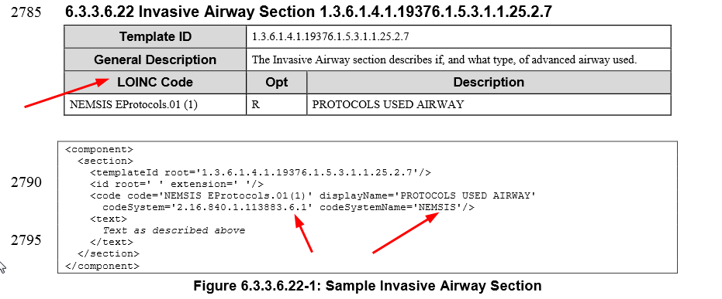

- The Table says LOINC Code
- The example uses the OID for LOINC
- The codeSystemName in the example is NEMSIS. This codeSystemName does not match the first two items.
- Is the coded value “NA – NEMSIS Escene 0.7” or is the “NA – “ a prefix to indicate this is not LOINC. It is confusing, especially because it is not done this away for the other two sections that use NEMSIS.

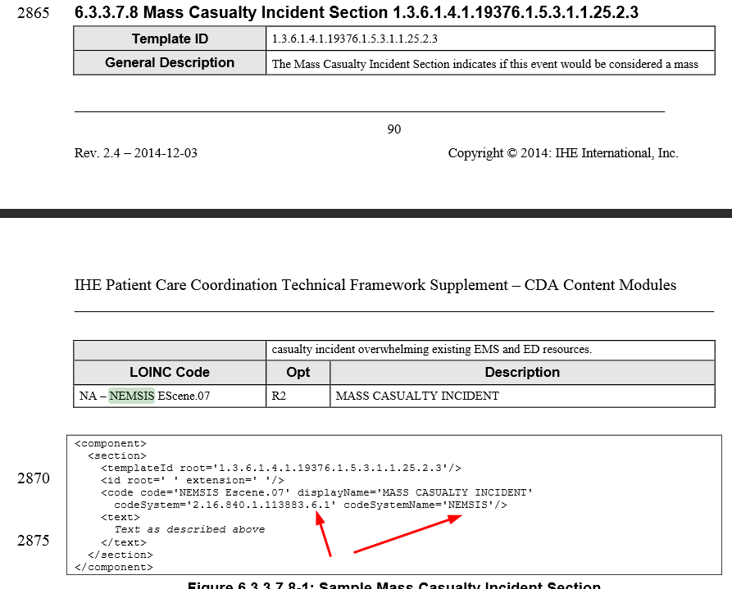

Rationale for Change:

- The Table says LOINC Code
- The example uses the OID for LOINC
- The codeSystemName in the example is NEMSIS. This codeSystemName does not match the first two items.

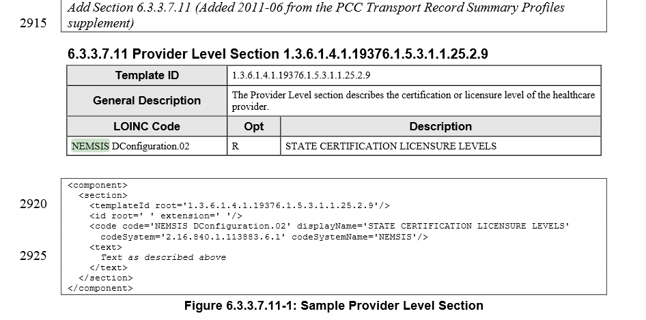

Replace Section 6.3.3.6.22 by the following:

6.3.3.6.22 Invasive Airway Section 1.3.6.1.4.1.19376.1.5.3.1.1.25.2.7
Template ID | 1.3.6.1.4.1.19376.1.5.3.1.1.25.2.7
General Description | The Invasive Airway section describes if, and what type, of advanced airway used.  The Invisive Airway section is derived from DEEDS LL1832-6 NEMSIS_45_protocol used / Airway/Airway-failed/Airway-obstruction/foreign body/Airway-paralytic (RSI), Airway-Rapid Sequence Induction (RSI-Paralytic)/Airway-sedation assisted (nonparalytic)/Cardiac arrest- asystole, etc PROTOCOLS USED
LOINC Code | Opt | Description
67537-1 | R | PROTOCOLS USED NEMSIS

<component>
<section>
<templateId root='1.3.6.1.4.1.19376.1.5.3.1.1.25.2.7'/>
<id root=' ' extension=' '/>
<code code='67537-1' displayName='PROTOCOLS USED NEMSIS'
codeSystem='2.16.840.1.113883.6.1' codeSystemName='LOINC'/>
<text>
Text as described above
</text>
</section>
</component>
Figure 6.3.3.6.22-1: Sample Invasive Airway Section
Replace Section 6.3.3.7.8 by the following:

6.3.3.7.8 Mass Casualty Incident Section 1.3.6.1.4.1.19376.1.5.3.1.1.25.2.3
Template ID | 1.3.6.1.4.1.19376.1.5.3.1.1.25.2.3
General Description | The Mass Casualty Incident Section indicates if this event would be considered a mass casualty incident overwhelming existing EMS and ED resources.
LOINC Code | Opt | Description
67490-3 | R2 | Mass casualty incident NEMSIS

<component>
<section>
<templateId root='1.3.6.1.4.1.19376.1.5.3.1.1.25.2.3'/>
<id root=' ' extension=' '/>
<code code='67490-3' displayName='EMS scene Narrative NEMSIS'
codeSystem='2.16.840.1.113883.6.1' codeSystemName='LOINC'/>
<text>
Text as described above
</text>
</section>
</component>
Figure 6.3.3.7.8-1: Sample Mass Casualty Incident Section
Replace Section 6.3.3.7.11 by the following:

6.3.3.7.11 Provider Level Section 1.3.6.1.4.1.19376.1.5.3.1.1.25.2.9
Template ID | 1.3.6.1.4.1.19376.1.5.3.1.1.25.2.9
General Description | The Provider Level section describes the certification or licensure level of the healthcare provider.
LOINC Code | Opt | Description
71580-5 | R | Crew member level NEMSIS

<component>
<section>
<templateId root='1.3.6.1.4.1.19376.1.5.3.1.1.25.2.9'/>
<id root=' ' extension=' '/>
<code code='71580-5' displayName='Crew member level NEMSIS’
codeSystem='2.16.840.1.113883.6.1' codeSystemName='LOINC'/>
<text>
Text as described above
</text>
</section>
</component>
Figure 6.3.3.7.11-1: Sample Provider Level Section

